Additional File 3: The Most enriched GO terms During the different time points as compared to the control
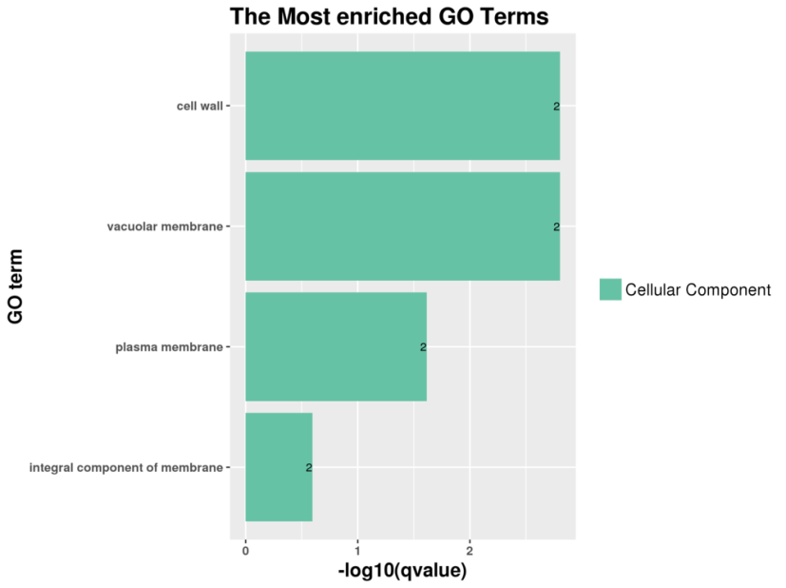
0hr vs 1hr

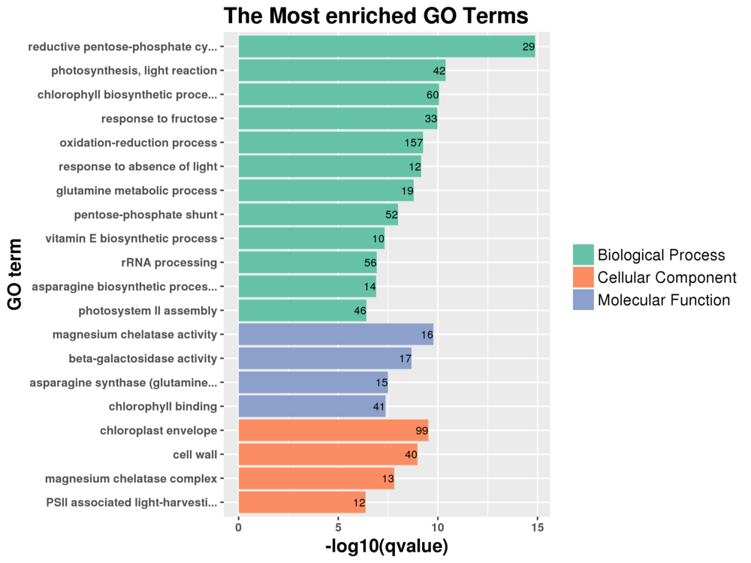
0hr vs 6hr

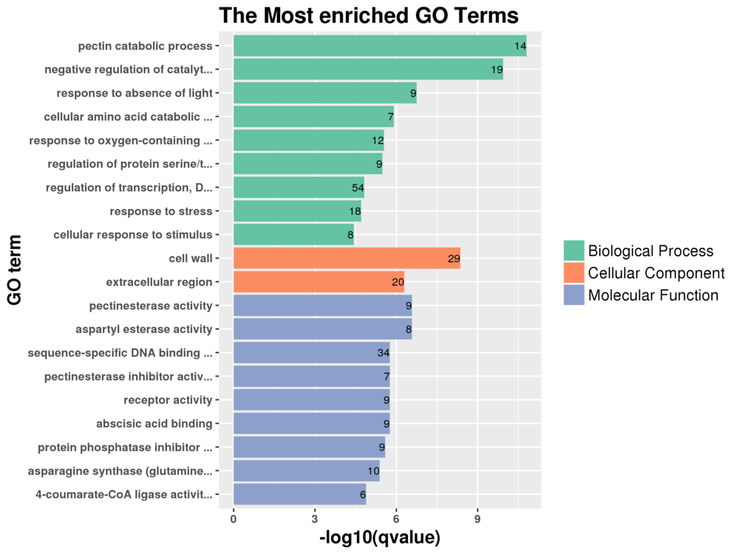
0hr vs 12hrs

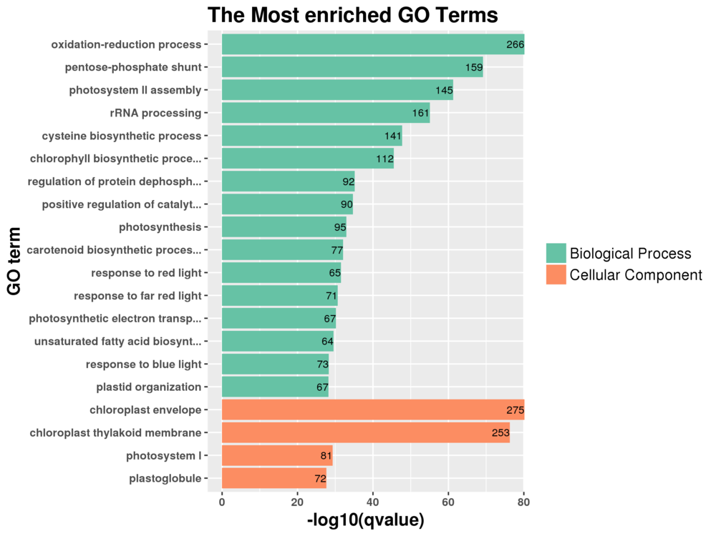
0hr vs 48hrs

